**Assignment:**

Module 1 :- understanding of hardware and its components

**Section 1 :- Multiple choice**

1. Which of the following is not a component of the CPU?

1.ALU

2.RAM

3.CU

4. 1 AND 3 both

• **ANS:- RAM**

1. What is the function of RAM in a computer?

o **RAM :-**  is like your computers short term memory, here what it does.

* + **Fast Data Access:** RAM allows the CPU to quickly retrieve data that is actively being used by applications. The faster the RAM, the quicker the system can process tasks.

* + **Temporary Storage:** Data in RAM is volatile, meaning it only persists while the system is powered on. Once the computer is shut down or restarted, any data stored in RAM is erased.

* + **Multitasking Support:** RAM enables your computer to run multiple applications at once. It holds the programs and data that are currently being used, which allows switching between tasks without slowing down performance.

* + **Improved Performance:** More RAM typically leads to better system performance, especially when dealing with memory-intensive tasks like video editing, gaming, or running virtual machines.

1. Which of the following is a primay storage device?

1.HDD

2.SSD

3.SD CARD

1. 1 AND 2 BOTH

1. **ANS :- 4. 1 AND 2 BOTH**

1. What is the purpose of GPU?

**ANS:- GPU** stands for Graphics Processing Unit. It is a specialized electronic circuit designed to accelerate the creation and rendering of images, videos, and animations. It performs rapidmathematical calculations, primarily for rendering graphics, but modern GPUs are also widely used for parallel processing tasks such as machine learning, video editing, and scientific simulations.

**SECTION 2 :-** TRUE OR FALE

1. True or False: The motherboard is the main circuit board of a computer where other components are attached.

**ANS :-**True

1. True or False: A UPS (Uninterruptible Power Supply) is a hardware device that provides emergency power to a load when the input power source fails.

**ANS :-** True

1. True or False: An expansion card is a circuit board that enhances the functionality of a component.

**ANS :-** True

**SECTION :-3 SHORT ANSWER**

1. Explain the difference between HDD and SSD?

# Feature HDD (Hard Disk Drive) SSD (Solid State Drive)

**Speed** Slower Much faster

**Durability** Prone to damage ( moving parts) More durable (no moving parts)

|  |  |  |
| --- | --- | --- |
| **Feature** | **HDD (Hard Disk Drive)** | **SSD (Solid State Drive)** |
|  |  |  |
| **Noise** | Produces noise during operation | Silent operation |
|  |  |  |
| **Power**  **Consumption** | Higher | Lower (more energy efficient) |
|  |  |  |
| **Cost** | Cheaper per GB | More expensive per GB |
|  |  |  |
| **Lifespan** | Can wear out mechanically over time | Flash cells degrade over time, but lasts long |
|  |  |  |
| **Use Cases** | Good for large, inexpensive storage | Best for speed-sensitive tasks (OS, apps) |

1. Describe the function of BIOS in a computer system?

**ANS**:- BIOS stands for BasicInput/Output System. It is firmware stored on a chip on the motherboard that initializes and manages communication between the computer's hardware and operating system.

Main Functions of BIOS:

* 1. Boot Loader:- Locates and loads the operating system from the hard drive, SSD, or other bootable device into memory

* 1. Provides Runtime Services:- Offers low-level services to the OS and other software for accessing hardware components.

* 1. BIOS Setup Utility:- Allows users to configure hardware settings like boot order, system time, and password protection.

* 1. Power-On Self-Test (POST):- Ensures everything is working properly before loading the OS.

1. List and briefly explain three input devices commonly used with computers.?

* **Keyboard**
* **Function:** Used to enter text, numbers, and commands into the computer.
* **How it works:** Each key press sends a signal to the computer, which is interpreted as a specific character or action.
* **Mouse**
* **Function:** A pointing device used to interact with graphical elements on the screen (e.g., icons, buttons).
* **How it works:** Detects movement and clicks, allowing users to move a pointer and select or drag items.
* **Scanner**
* **Function:** Converts physical documents or images into digital form.
* **How it works:** Uses light sensors to capture the image/text and convert it into a digital file for storage or editing on the computer.

**Section 4:-**  Practical Application

11. Identify and label the following components on a diagram of a motherboard?

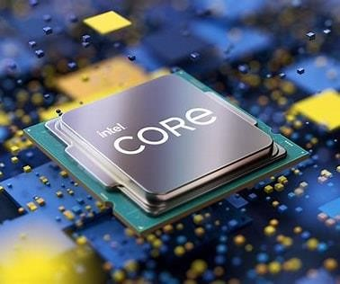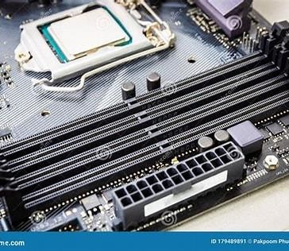

**CPU**

RAM SLOT

|  |
| --- |
| PCI – E  SLOT |

## SATA

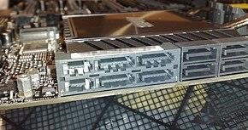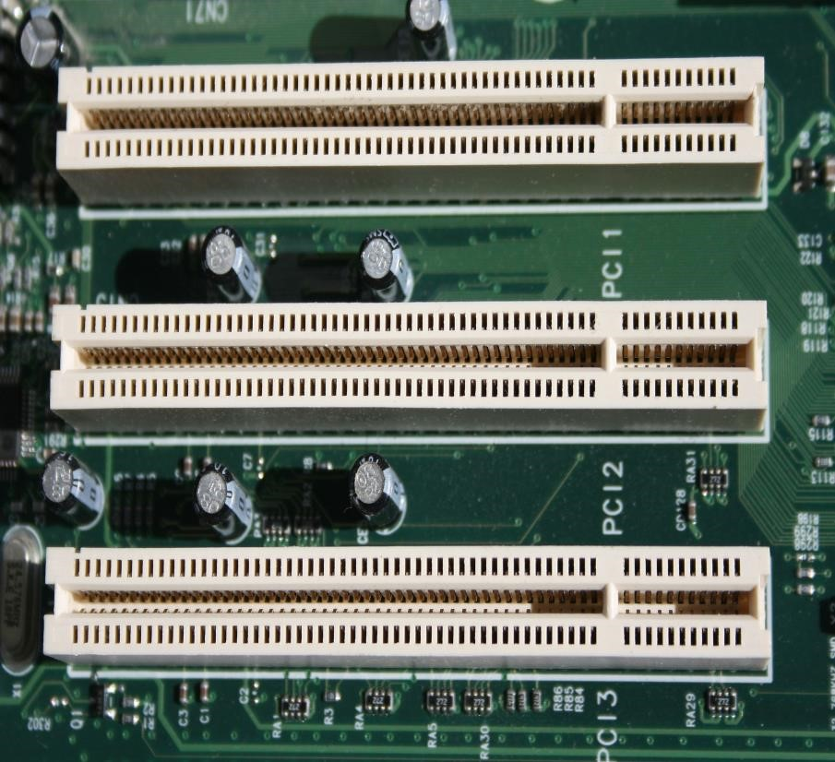

CONNECTOR

1. Demonstrate how to install a RAM module into a computer.?

* + - Turn off the computer and unplug it.

* + - Open the side panel of the CPU case.

* + - Locate the RAM slots on the motherboard.

* + - Align the RAM module with the slot (match the notch).

* + - Press firmly until the side clips snap into place.

* + - Close the case, plug in the PC, and turn it on.

* + - Check in BIOS or system settings to confirm RAM is detected.

**SECTION :-5**  ESSAY:

1. Discuss the importance of proper cooling mechanisms in a computer system. Include examples of cooling methods and their effectiveness?

**ANS:-** Proper cooling is **critical** for maintaining system performance, stability, and longevity. Computers generate heat as they operate—especially high-performance components like the **CPU**, **GPU**, and **power supply**. Without adequate cooling, these parts can **overheat**.

Why Cooling Is Important:

Prevents Overheating:

* + Heat can damage the CPU, GPU, motherboard, and other parts.

* + Overheating may cause sudden shutdowns or system crashes.

* + Maintains Performance:

* + High temperatures trigger thermal throttling, where the CPU/GPU slows down to reduce heat.

* + Proper cooling helps maintain maximum performance.

* + Extends Hardware Lifespan:

* + Cooler components last longer.

* + Reduces the risk of burnt circuits or damaged chips.

* + Improves Stability:

* + A well-cooled system is less likely to freeze, lag, or crash

Proper cooling keeps your computer **fast, stable, and safe**. Choose the right cooling method based on your needs and always ensure your system stays within safe temperature limits.

1. Explain the concept of bus width and its significance in computer architecture?

**ANS ;- Bus width** refers to the **number of bits** that a computer’s data bus can carry **simultaneously**. It is a key part of the **system bus**, which transfers data between components like the CPU, RAM, and other peripherals.

**Types of Buses in a Computer:**

* + - * Data Bus – Carries actual data (bus width applies here most directly)

* + - * Address Bus – Carries memory addresses

* + - * Control Bus – Carries control signals

EXAMPLE:-

* + - * **A 32-bit bus can transfer 32 bits (4 bytes) of data at a time.**

* + - * **A 64-bit bus can transfer 64 bits (8 bytes) at a time.**

**Bus width** is a fundamental factor in how **fast** and **efficiently** a computer can process and move data. Wider buses help increase overall system performance, especially in modern 64-bit systems.